

Name: GEETHASRI THIRUNAHARI

Gmail: [geethasrithirunahari@gmail.com](mailto:geethasrithirunahari@gmail.com)

**1.Create two S3 bucket in different regions, upload a file in one S3 bucket and transfer the same file from one S3 bucket to other S3 bucket.**

Create S3 bucket.

Log in to the AWS management console.

Click on the S3 bucket in dashboard.

Click on “create bucket”.

Enter a unique bucket name and select a region

(ap-south-1-mumbai).

Choose the bucket versioning and enable it.

Click on “create bucket”.

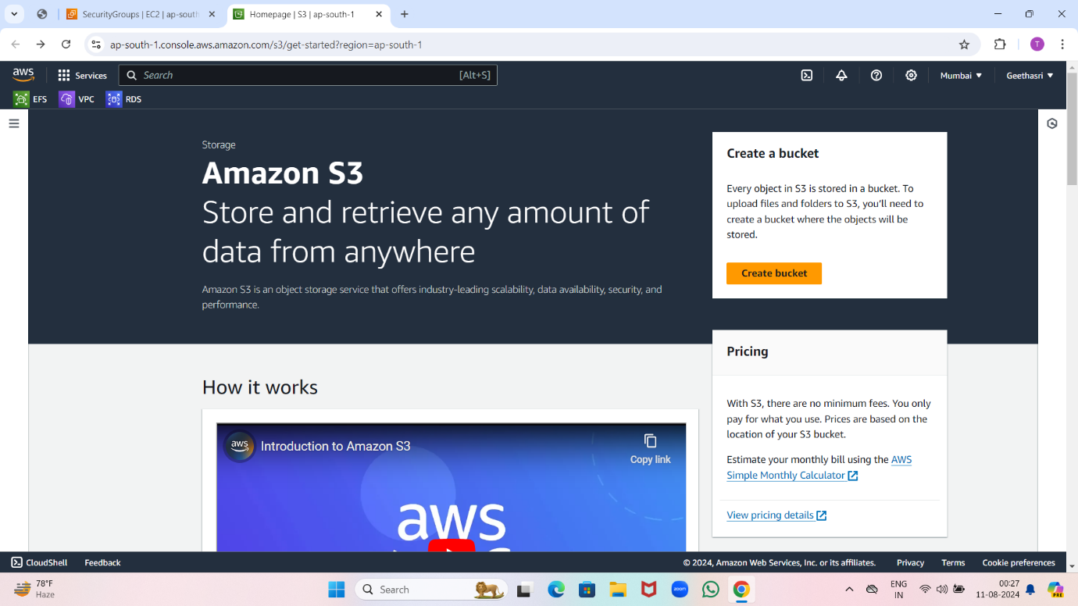

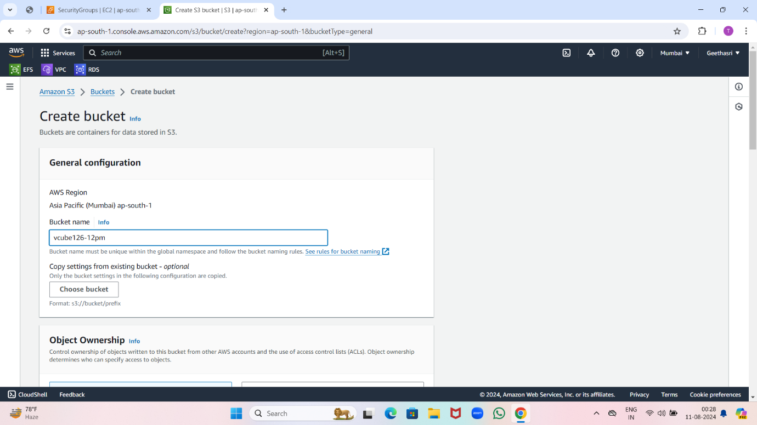

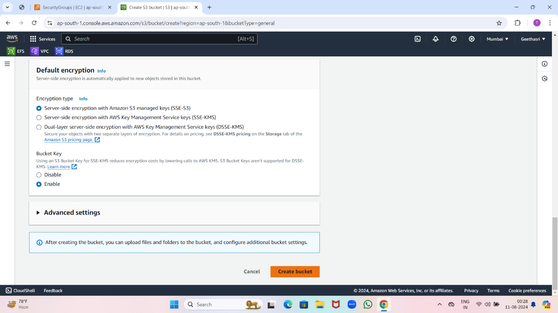

Upload a file in it.

Select the bucket you want to upload to.

Click “upload”and select “files”.

Choose the file you want to upload.

Click “open” to start the upload process.

Click “upload’ to complete the upload.

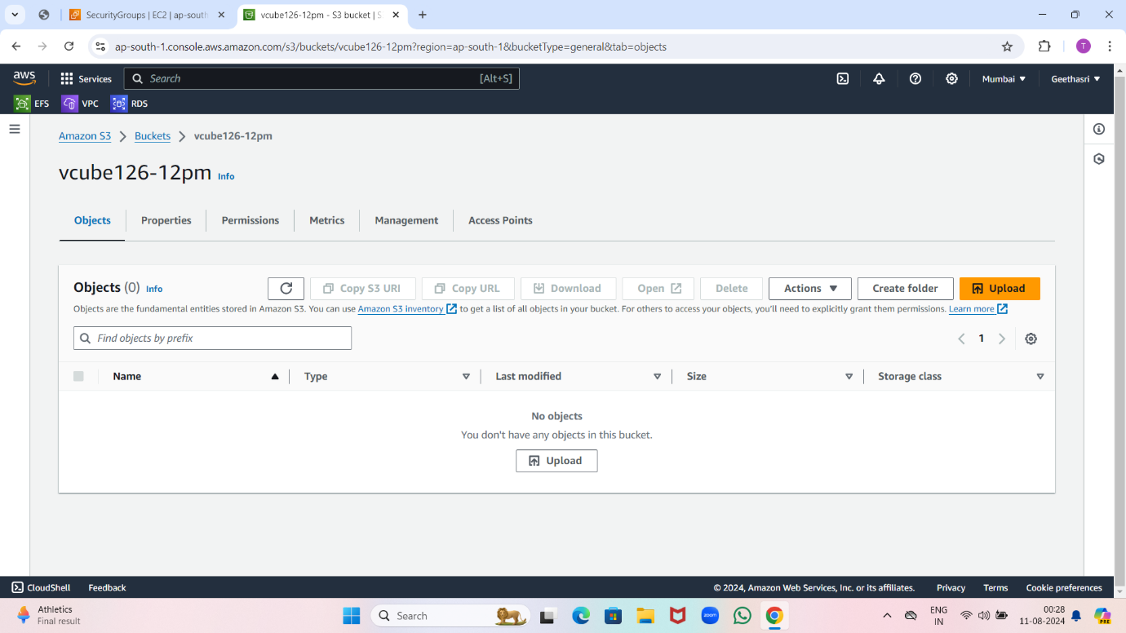

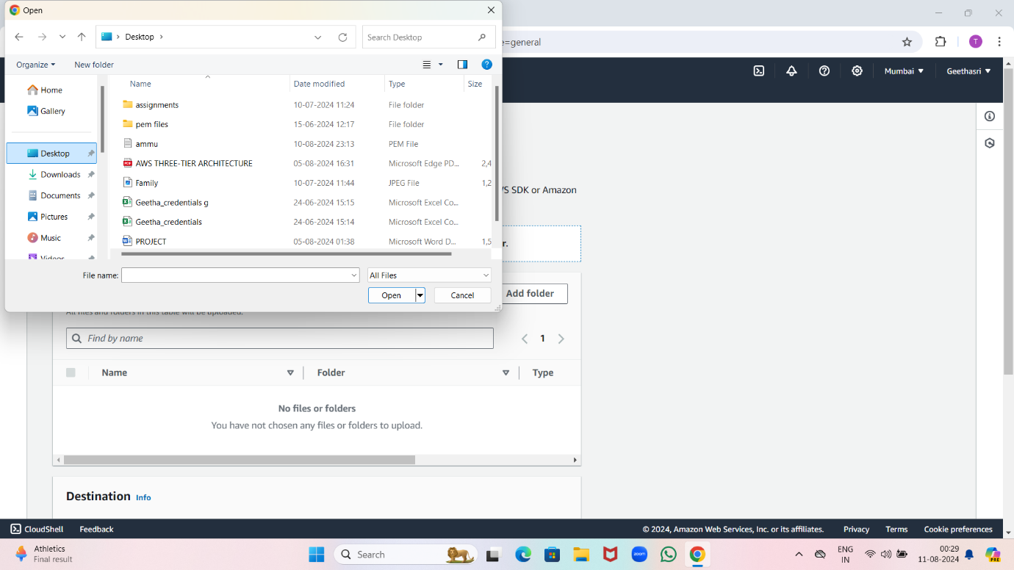

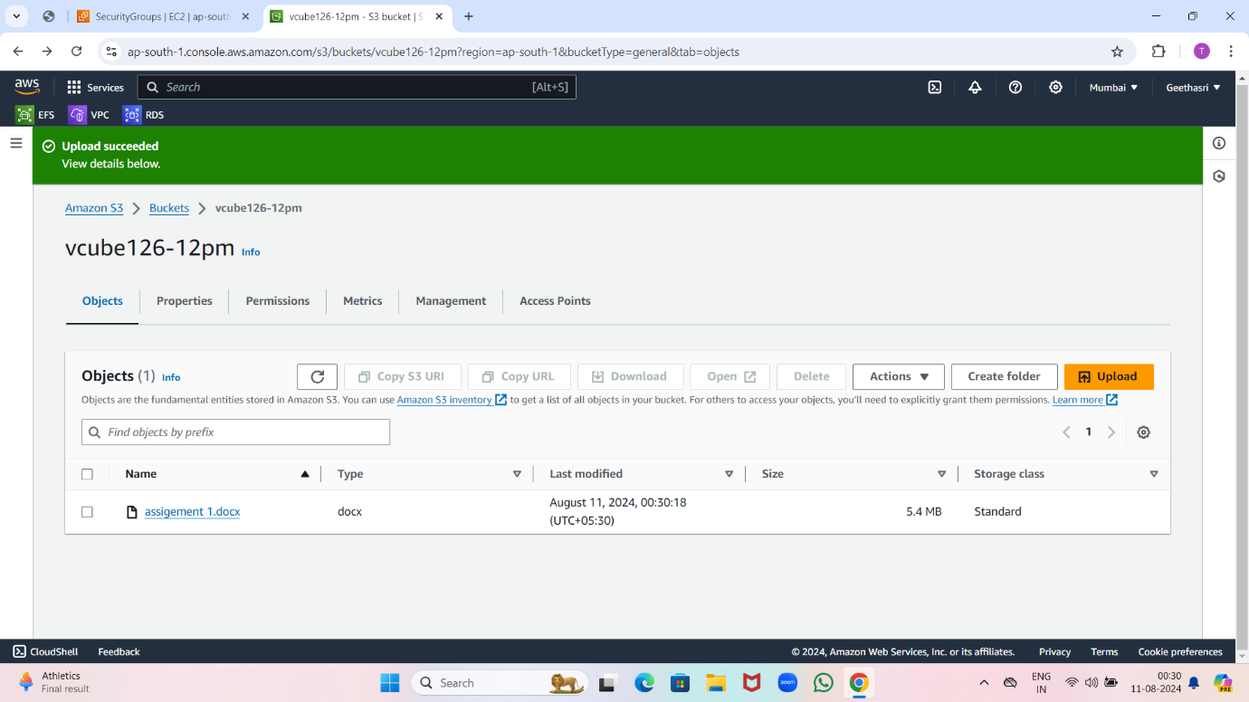

Now choose one more region and create a bucket.

Click on “create bucket”.

Select a region (ap-southeast-1-singapore).

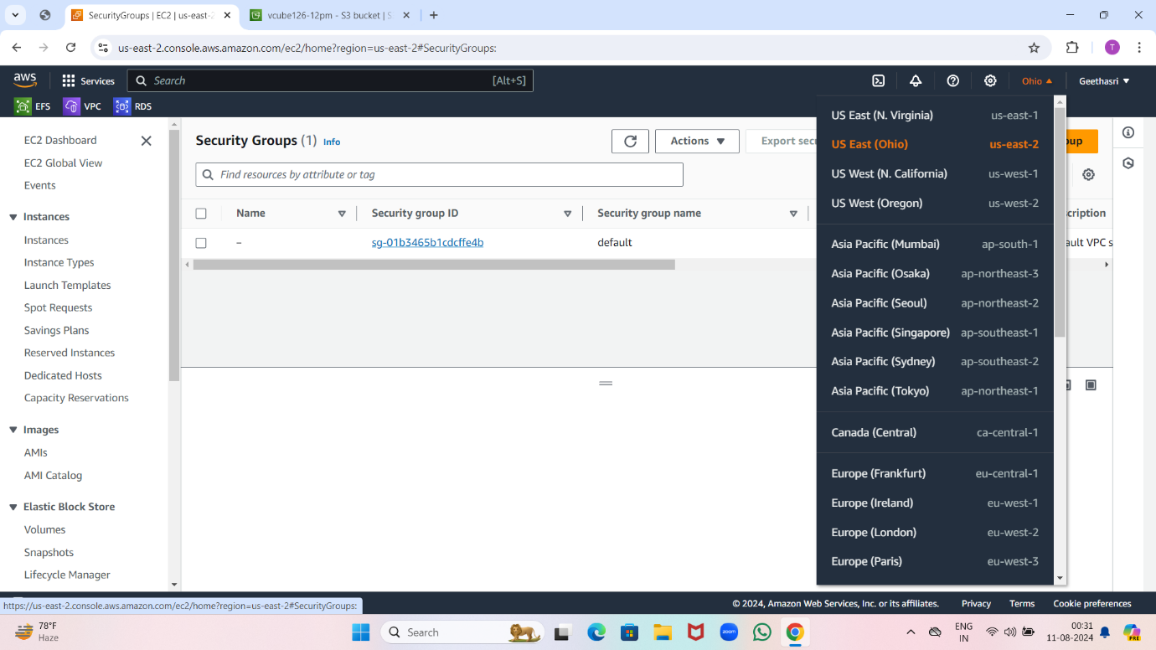

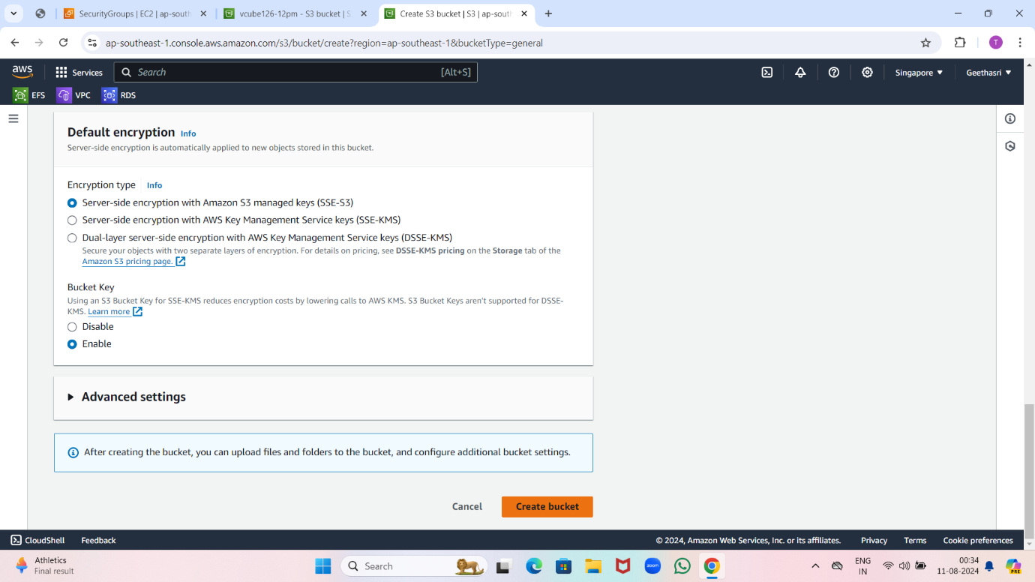

Go to source bucket(singapore).

Click on properties and edit bucket versioning and enable it and save changes.

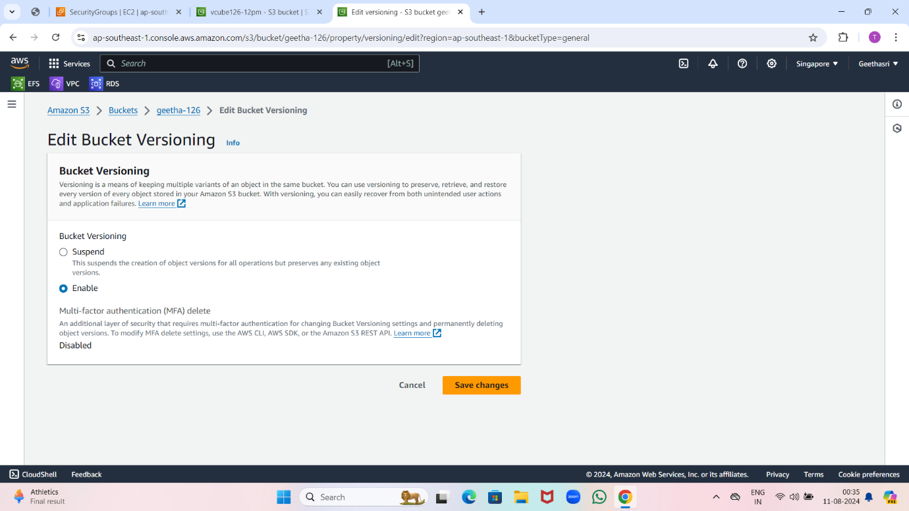

Go to management come down and create replication rule.

Give name to it and select apply to all objects in the bucket.

Choose destination bucket and click on choose path.

Click on new rule and select replication time control and save it choose yes submit it.

Click on brows select destination (mumbai) click on choose path and save it.



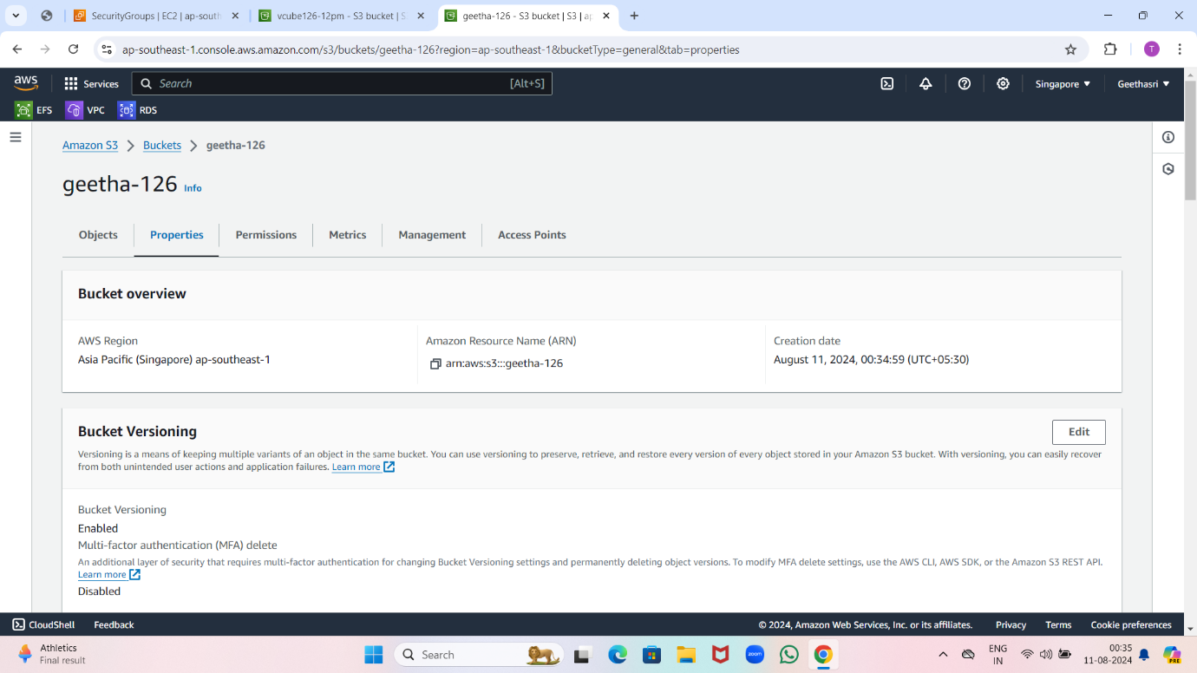



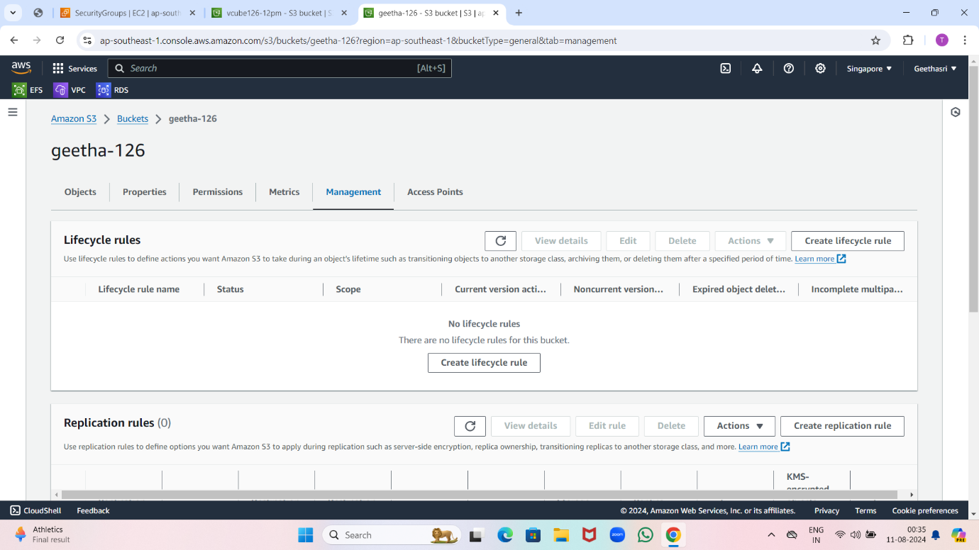

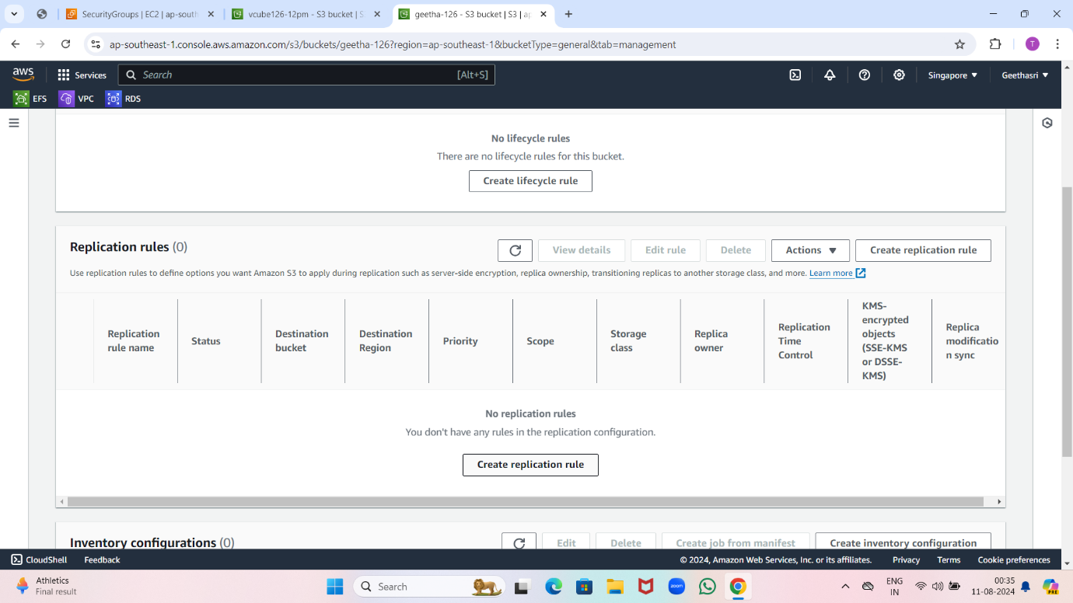

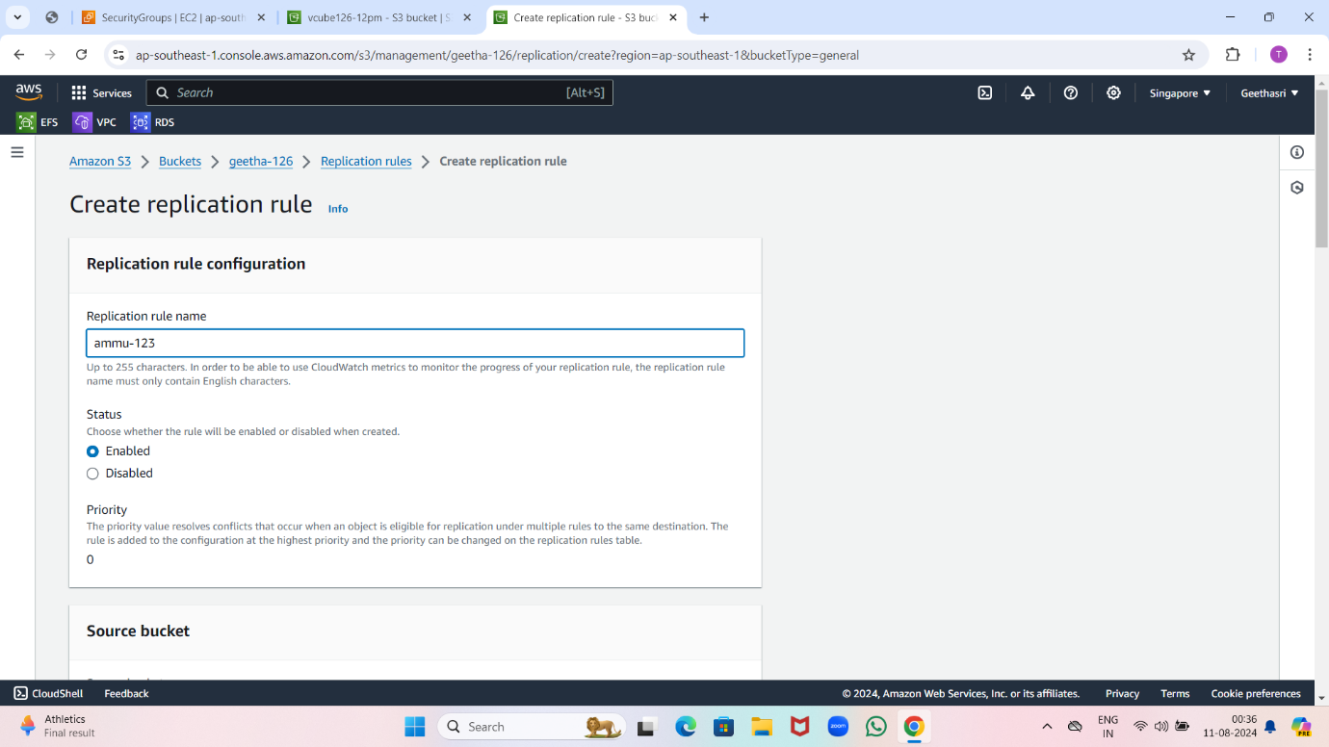

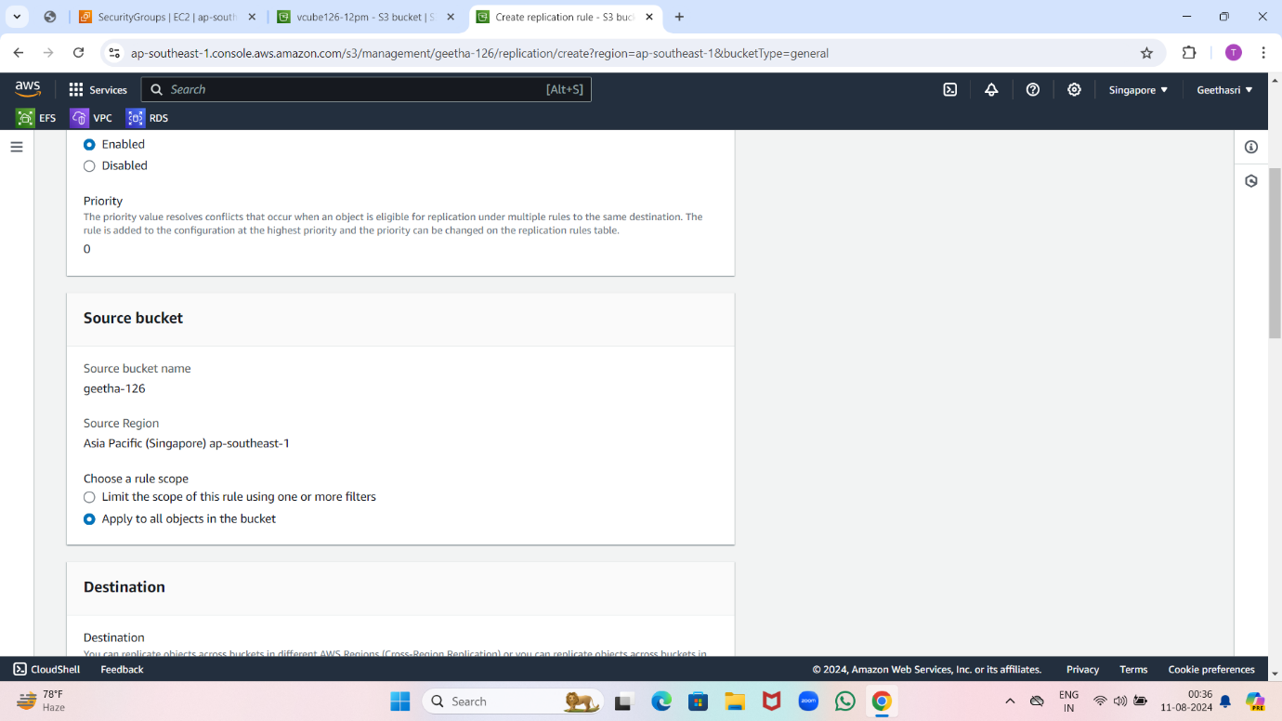

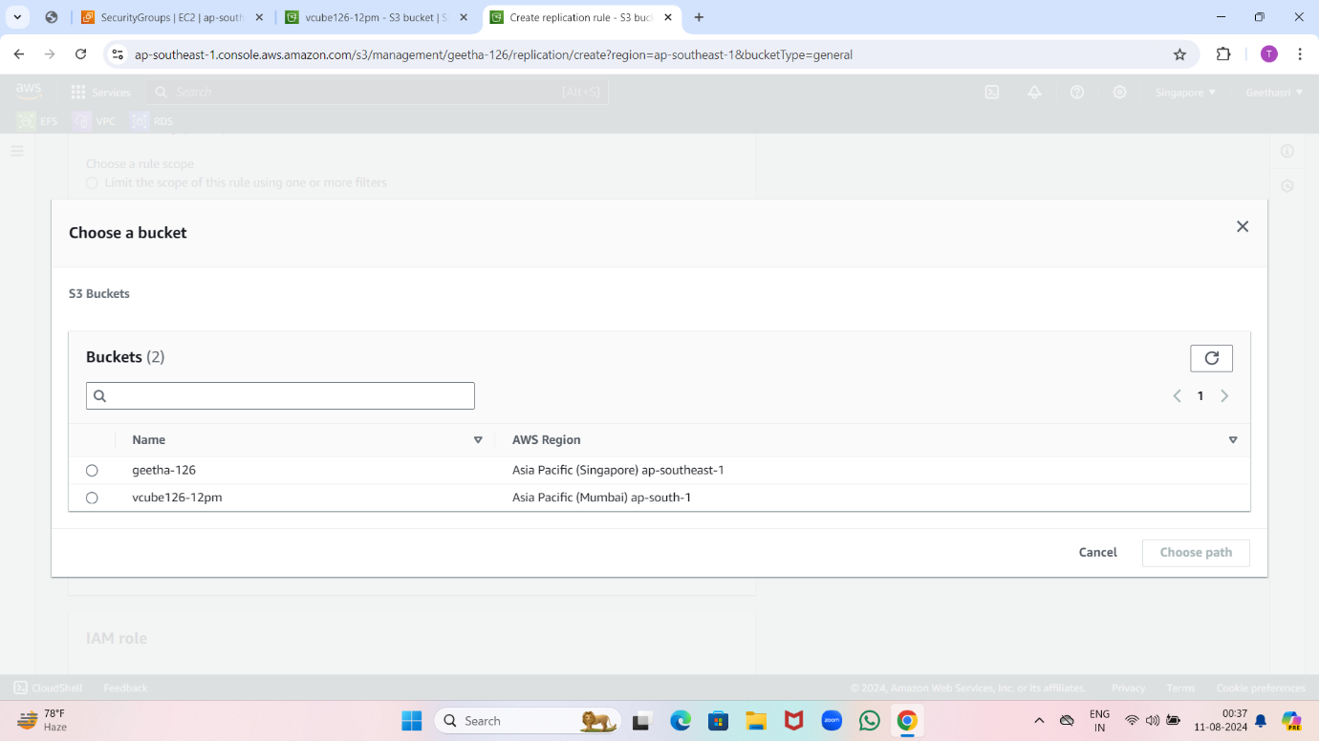

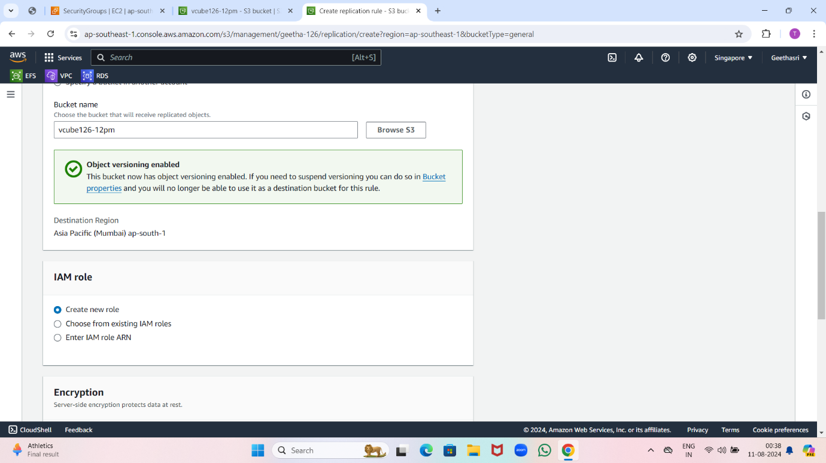

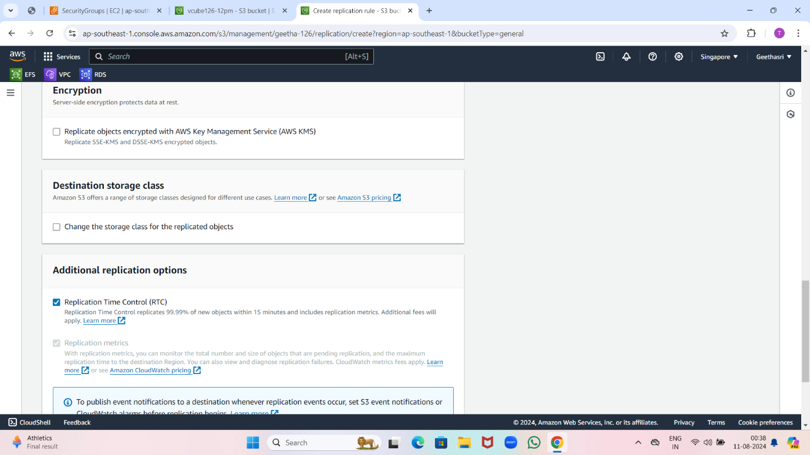

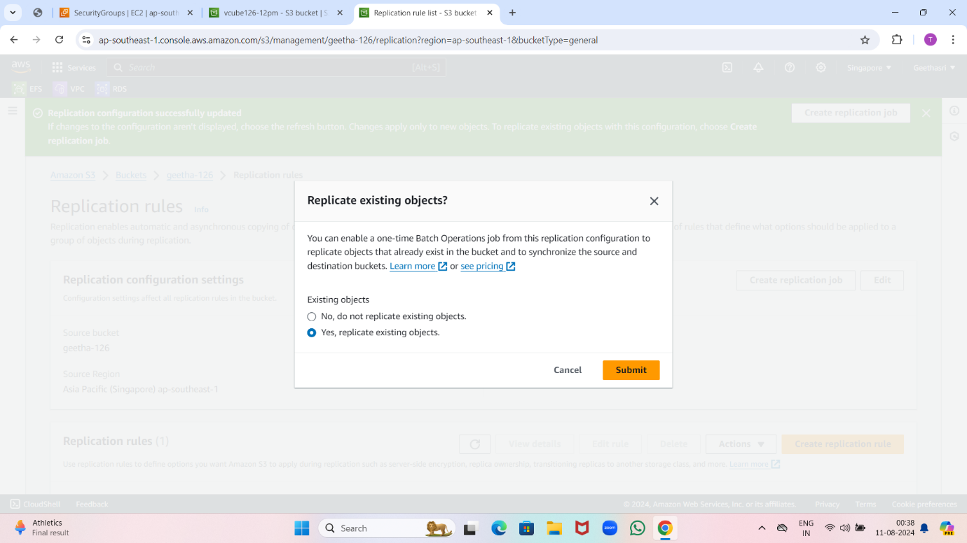

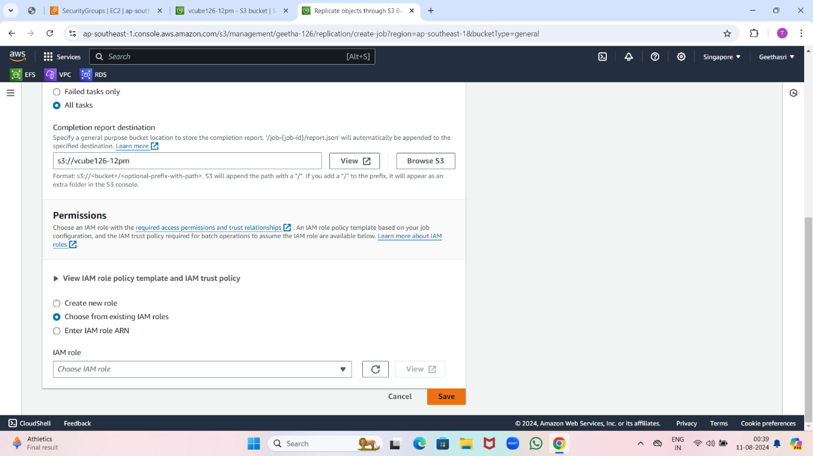

Now upload a file in source bucket (singapore) .

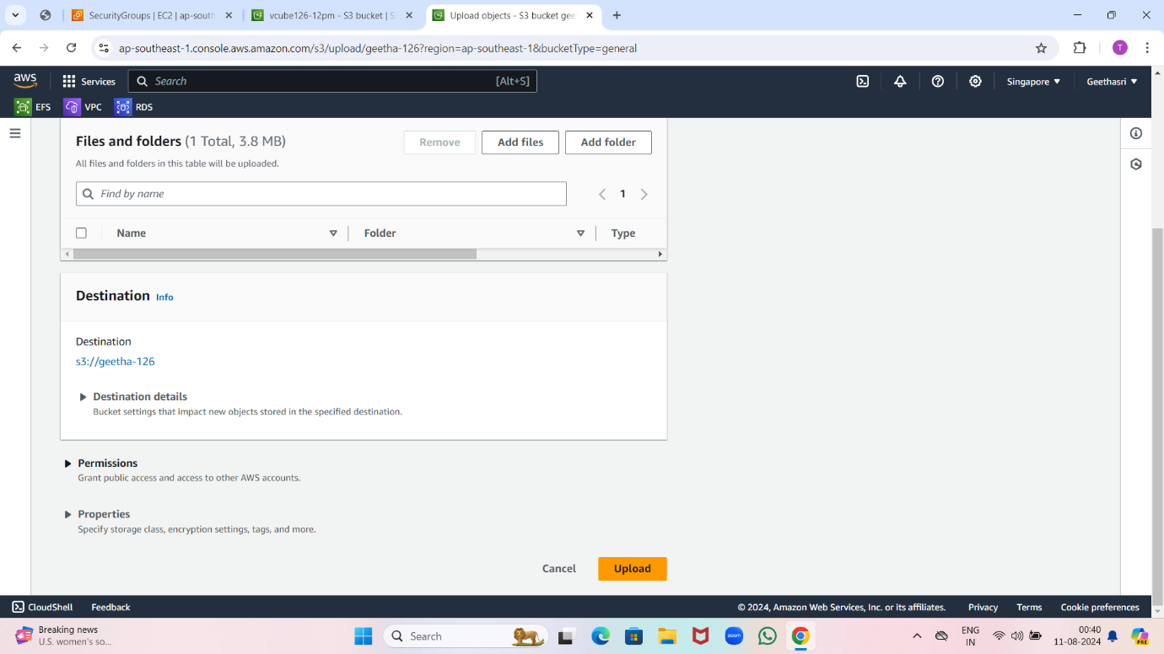

Now go and check in destination bucket (mumbai) it will display.

